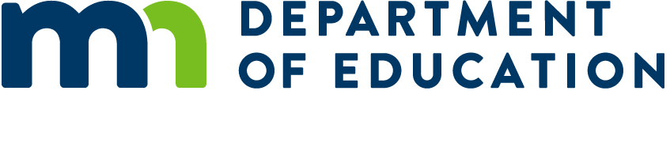

# How to Use Business Frameworks and Table C

**March 2024**

## Section 1: Frequently Asked Questions

### What is Table C?

Table C is a document developed by the Minnesota Department of Education (MDE) which consolidates the program codes, course codes, and teacher licenses associated with career and technical education (CTE) in the various program career fields. These career fields include: Agriculture, Food, and Natural Resources; Business and Marketing; Family and Consumer Sciences; Health Sciences; Trade and Industry; and Work-Based Learning.

Information to each career field area is found on its own spreadsheet tab in the Table C document. Information specific to Business and Marketing programs is found on the “Business & Marketing” tab.

### Where do I find Table C?

The Table C document is one of the resource documents provided on the MDE Program Approval web page: <https://education.mn.gov/MDE/dse/cte/progApp/>

### What license(s) do I need to teach career and technical education (CTE) business and marketing courses in Minnesota?

Since 2001, the only career and technical education (CTE) Business/Marketing teaching license issued in Minnesota has been the 140050 Business license. This license allows a teacher to teach ANY course on the Business Table C, including courses in the Administrative Support (140710) program, the Marketing (040800) program, and any of the Work-Based Learning programs (9090 or 9095) for Business.

In addition to the 140050 license--which would be the license a school district would apply for when seeking an out-of-field permission (OFP) for a teacher from another licensure area to deliver business courses—there are several “legacy” licenses which are no longer issued but that can continue to be renewed and that are still eligible as CTE Business licenses. Those include:

* 040800 Marketing Occupations (for 040800 programs)
* 049090 Teacher-Coordinator, Marketing Occupations Co-op Programs (for 049090 and 049095 programs)
* 140100 Accounting (for 140710 programs)
* 140120 Banking and Finance (for 140710 programs)
* 140710 Administrative Support Occupations (for 140710 programs)
* 149090 Teacher-Coordinator, Business Occupations Co-op Programs (for 149090 and 149095 programs)

### Does our school need to use the exact course names shown on Table C?

NO—course names can be determined locally. What MDE will review for Program Approval is the alignment of course outcomes to the performance indicators and benchmarks in the Minnesota Business Frameworks for that course, not its course name. What IS IMPORTANT to consider regarding course names is that they are intended to identify student development of technical and employability skills aligned with a Business/Marketing career pathway. Course names such as “DigiTools,” “Fun with Computers,” etc. may not project this kind of career preparation to future employers. In that regard, the course names provided on Table C may provide a useful “guide” for course name considerations.

### What are the “Minnesota Business Frameworks”?

The Minnesota Business Frameworks are similar to “standards” and provide guidance for local school district CTE Business and Marketing programs as to the content and rigor MDE would expect to see for courses to be accepted in the Program Approval process. Local control allows school districts to align course outcomes to the performance indicators and benchmarks found in the Frameworks that have been developed for each course on Table C, selecting those that best meet the needs of their students and regional workforce development.

The Minnesota Business Frameworks are a collection of documents (see screenshot below) organized by the career clusters identified on the Business and Marketing Table C. The collection also includes an “Introduction” document that may benefit district administrators, district curriculum committees, and your CTE Business Advisory Committee.



Figure : Minnesota Business Frameworks on MDE Website

Each “cluster Framework” document begins with eight strands of Employability Skills recommended to be embedded within the courses in that cluster. These employability skills are typically taught in combination with the technical skills that make up the course objectives for career pathway development—rather than being taught in isolation. These employability skills are typically evaluated with formative assessments rather than the type of summative assessments that would be recorded in a grade book.

“Course Frameworks” have been created for each course on Table C. They have been developed to represent higher-order thinking outcomes—“application and synthesis,” not just “know and understand.” Note that in some cases the “rigorous” courses in which students can earn college credits have student outcomes for working with advanced content that may still not quality as CTE if students are only asked to “know and understand” the content and not apply it in some way toward career pathway development.

The Performance Indicators identify the key technical skills recommended for development within each course. The Benchmarks identify multiple ways in which student mastery of the Performance Indicators could be assessed. (In practice, a teacher may choose to measure an indicator with as few as 1-3 benchmarks as appropriate for the course and the indicator. Using ALL benchmarks provided in a Framework for a given indicator is NOT required!) Minnesota Rule 3505 requires that approved CTE programs use **“authentic assessments of knowledge and skills”**—which should be utilized to accomplish the benchmarks selected for each course. Alignment to these elements helps to ensure that Business and Marketing program courses include the academic integration, employability skills, and technical skills that meet expectations of Minnesota Rule and the Perkins V federal legislation. MDE will be assessing this alignment during the Program Approval process.

### Where do I find the Minnesota Business Frameworks?

The Business and Marketing Frameworks organized by career clusters identified on [Table C](https://education.mn.gov/mdeprod/idcplg?IdcService=GET_FILE&dDocName=049191&RevisionSelectionMethod=latestReleased&Rendition=primary) are found at the bottom of the MDE Business, Marketing, and Information Technology web page: <https://education.mn.gov/MDE/dse/cte/prog/biz/>

### When do I use these Table C and Frameworks documents?

Aligning course outcomes to Minnesota State Frameworks and/or national standards for Program Approval:

* Evaluating and updating existing courses
* Developing new courses
* Local curriculum review cycle

Evaluating current Business/Marketing program alignment (courses to drop, courses to add) to Business/ Marketing career pathway workforce needs identified in your consortium Comprehensive Local Needs Assessment (CLNA):

* Evaluating alignment of current secondary program and Program of Study
* Creating new secondary programs and collaborating on Programs of Study with a postsecondary partner

### How do I use these Table C and Frameworks documents?

That is what the information on the following pages is all about!

## Section 2: Curriculum Development Using Table C and Frameworks

### Evaluating and Aligning the “Purpose” of Each Course

The purpose of each CTE Business and Marketing course is often described in the narrative of a student registration guide and the syllabus course description. The overarching purpose for any career and technical education course should be “career pathway preparation.” A key objective of the MDE Program Approval process is to **assess the rigor of student outcomes and the alignment of intended outcomes** to Minnesota Business Frameworks (or national standards when appropriate) to achieve this career pathway preparation.

The course description, unit outline of course content, and alignment to state Performance Indicators, should help answer the following questions related to career pathway preparation:

* Does each course demonstrate development of career pathway employability skills and application of career pathway technical skills (i.e., alignment to Minnesota Business Frameworks performance indicators)?
* Is each course part of a sequence of related career cluster courses that prepare students for high skill, high wage, in-demand career pathways?
* Does the sequence of courses demonstrate advancement beyond general or “introductory” courses to those developing more specific career preparation content knowledge and technical skills?

These questions should be applied to both the evaluation of current course offerings and the development of new secondary Business and Marketing courses.

#### Aligning Local Standards to State Performance Indicators

School districts may use several different terms they want teachers to apply in expressing their course outcomes: performance indicators, objectives, learning targets, essential learner outcomes, etc. Regardless of the terminology used, Minnesota CTE courses should identify intended student outcomes that will prepare them for further career pathway study and career opportunities.

This is typically done by identifying course alignment to performance indicators from the Minnesota Business Frameworks, either in course syllabi or in other district curriculum materials (i.e., district curriculum maps, unit guides, school board policies on standards, etc.). This evidence can take several forms in support of meeting requirements for [Minnesota Statute 120B.022 on Elective Standards](https://www.revisor.mn.gov/statutes/cite/120B.022): ***“Subdivision 1. Elective standards. A district must establish and regularly review its own standards for career and technical education (CTE) programs. Standards must align with CTE frameworks developed by the Department of Education, standards developed by national CTE organizations, or recognized industry standards.”***

#### How to Align Course Outcomes to State Performance Indicators

This section provides suggested action steps for aligning course outcomes to state Performance Indicators. Note that your school district may have procedures in place that also must be followed for the development of new courses and/or the revision of existing courses.

**New Courses:**

1. Access the Business and Marketing tab on the [Table C](https://education.mn.gov/mdeprod/idcplg?IdcService=GET_FILE&dDocName=049191&RevisionSelectionMethod=latestReleased&Rendition=primary) document. Review the placement of the new course within the sequence of other related courses currently being offered in that career cluster.

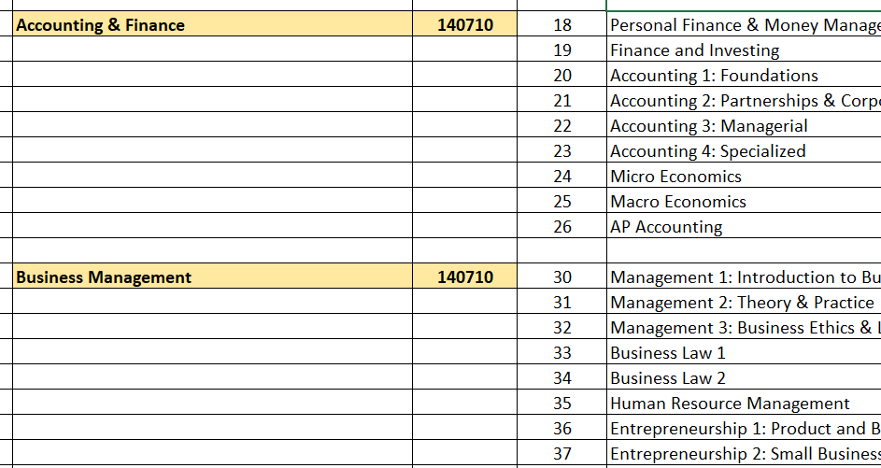

Figure : Table C Programs, Course Codes, and Course Titles

Continue to step 2 if the new course CAN be considered part of a sequence of courses preparing students for high-need career pathway opportunities.

1. Review the sample course description found on Table C as a foundation for the content to be developed for the new course. (Double click the cell in column F to display the full course description.)

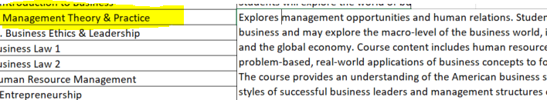

Figure : Course Descriptions on Table C

1. Access the [course Framework](https://education.mn.gov/MDE/dse/cte/prog/biz/) for the course that you are developing. (“Course Frameworks” are found starting approximately on pages 9 or 10 of most cluster Framework documents, following the first eight strands of performance indicators for Employability Skills.)

* Identify which of the Performance Indicators and Benchmarks from the course Framework you will align to your intended course content. (NOTE that for Program Approval a common expectation is that there will be at least 75-80% alignment.)

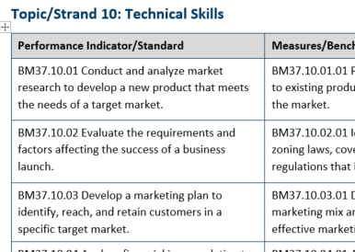

Figure : Course Framework Performance Indicators

* Create a course description and an outline of intended instructional units that will develop the technical skills identified in the Performance Indicators.

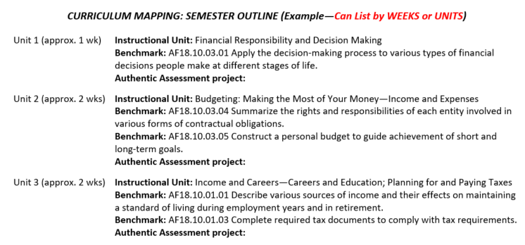

Figure : Sample Course Outline Identifying Instructional Units and Assessments

1. Using Table C and the Minnesota Business Frameworks, your draft syllabus/course outline/curriculum map should now include the following elements:

* Course description
* Course outline of intended instructional units
* Intended alignment of course outcomes to state Framework Performance Indicators

At this point, consider reviewing your draft of this course development with your Advisory Committee to incorporate their industry perspectives on content and outcomes to prioritize.

1. Use the Employability Skills strands at the beginning of each cluster Framework document (typically the first 8-9 pages) to develop the final two course aspects relevant to Program Approval process:

* 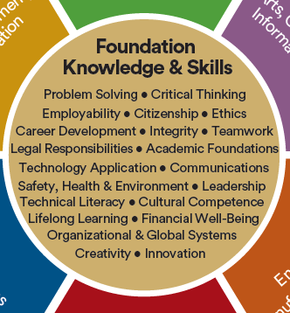How **student leadership development** (i.e., employability skills) will be incorporated throughout the course. When we embed instruction and activities to develop student leadership, the focus is not on the technical skill development of our Business programs. The focus is on youth development for the type of employability skills employers are seeking in their employees. Student leadership skills are listed in the center of the [Minnesota Career Wheel](https://www.minnstate.edu/system/cte/programs/documents/POS-Framework-2019-one-pager-with-explanation.pdf), including:
  + Problem solving
  + Creativity
  + Communication
  + Teamwork
  + Innovation
  + Critical Thinking
  + Decision making

Figure : Minnesota Career Wheel Foundational Knowledge and Employability Skills

The first eight strands of each cluster Framework document include Performance Indicators and Benchmarks for developing employability skills in Business and Marketing programs. Embed appropriate leadership skills with the technical skills you are developing in each course. Include them in your course design, and consider including this information on your syllabus.

* How **career development** (knowledge about, and skill development for, career pathway preparation) will be incorporated throughout the course. Your curriculum design (i.e., curriculum maps, course outlines, etc.) should include information on how you are embedding student opportunities to not only “explore” career pathway options but also to “prepare” for them through the knowledge and technical skills developed in each course. Your course documentation should describe the variety of career exploration, career preparation, and experiential learning opportunities that are embedded in your course.
* These should align with career pathways that are high wage, high skill, or in-demand in the Business and Marketing fields that have been identified in your consortium Comprehensive Local Needs Assessment (CLNA)—contact your Perkins consortium leader to obtain a copy of this document. Teachers can also utilize the [Career Pathways Tool](https://mn.gov/deed/data/data-tools/career-pathways-tool/) developed by the Minnesota Department of Employment and Economic Development (DEED) to connect occupational data with educational programming.

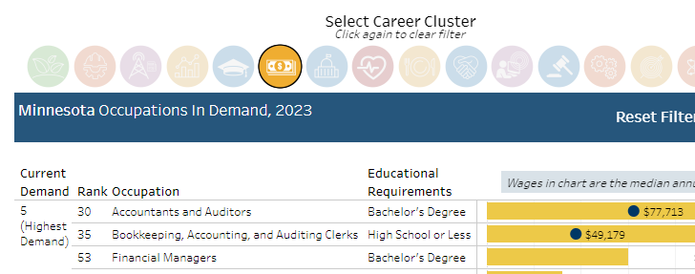

Figure 7: MN DEED Career Pathways Tool

* Another valuable resource for identifying career pathway opportunities for which your program should prepare students is the set of [CTE workforce trends reports developed by RealTime Talent](http://www.realtimetalent.org/research-2/cte-pathways/).

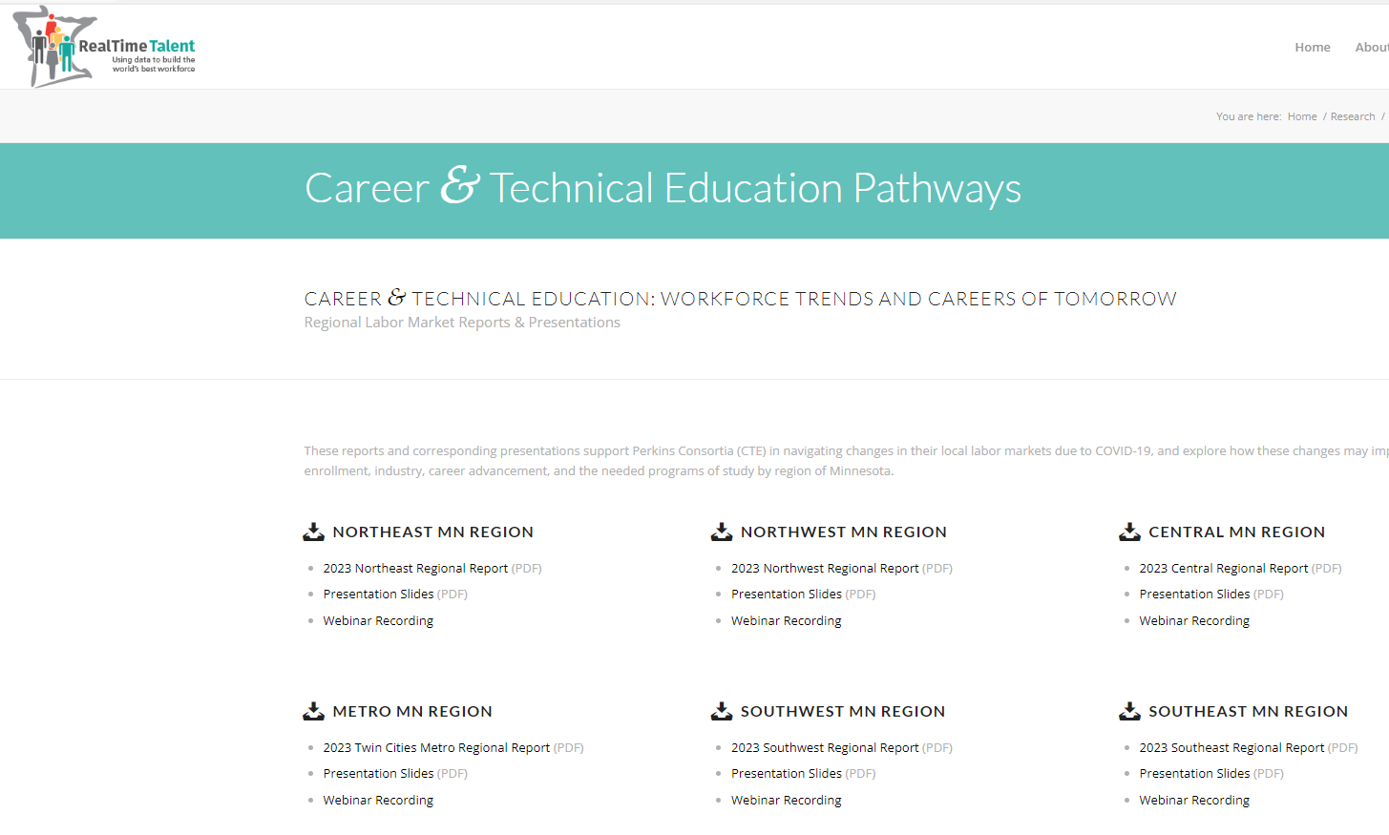

Figure 8: RealTime Talent Regional Workforce Talent Reports

1. Submit your curriculum materials (i.e., syllabus, curriculum map, course outline, Frameworks, etc.) to the appropriate administrators to follow any school district procedures in place for approval of new courses.
2. Once school district approval has been granted for the addition of your new course, work with [MDE Business and Marketing Specialist Dean Breuer](mailto:dean.breuer@state.mn.us) to submit this course as a Program Approval Amendment to your current approved program or as part of your five-year renewal application.

**Existing Courses:**

The review of existing courses is most often where teachers/districts begin the Program Approval process. Alignment of existing courses to Minnesota Business Frameworks follows steps similar to the development of new courses previously described:

1. Use the “C_FINAL” file provided by MDE Specialist Dean Breuer to determine the program and course number (from Table C) assigned to each course during your most recent Program Approval.
2. Go to the [MDE Business, Marketing, and Information Technology web page](https://education.mn.gov/MDE/dse/cte/prog/biz/) and scroll to the Business Frameworks documents found on the bottom of the page.
3. Access the [course Framework](https://education.mn.gov/MDE/dse/cte/prog/biz/) for the course that you are developing. (“Course Frameworks” are found starting approximately on page 10 of most cluster Framework documents, following the first nine strands of performance indicators for Employability Skills.)

* Identify which of the Performance Indicators and Benchmarks from the course Framework are aligned to your current course content. (NOTE that for Program Approval a common expectation is that there will be at least 75-80% alignment.)



Figure 9: Course Framework Performance Indicators

* Update your course description and curriculum outline of instructional units that develop the technical skills identified in the Performance Indicators. Updates should include new content needed to develop the content knowledge and application of technical skills that will prepare students for intended business career pathways.



Figure 10: Sample Course Outline Identifying Instructional Units and Assessments

1. Using Table C and the Minnesota Business Frameworks, your updated syllabus/course outline/ curriculum map should now include the following elements:

* Course description
* Course outline of intended instructional units
* Intended alignment of course outcomes to state Framework Performance Indicators

1. Use the Employability Skills strands at the beginning of the cluster Framework document (typically the first 8-9 pages) to update/incorporate the final two course aspects relevant to Program Approval:

* How **student leadership development** (i.e., employability skills) will be incorporated throughout the course. When we embed instruction and activities to develop student leadership, the focus is not on the technical skill development of our Business programs. The focus is on youth development for the type of employability skills employers are seeking in their employees. Student leadership skills are listed in the center of the [Minnesota Career Wheel](https://www.minnstate.edu/system/cte/programs/documents/POS-Framework-2019-one-pager-with-explanation.pdf).
  + The first eight strands of each cluster Framework document include Performance Indicators and Benchmarks for developing employability skills in Business and Marketing programs. Embed appropriate leadership skills with the technical skills you are developing in each course.

Figure 11: Minnesota Career Wheel Foundational Knowledge and Employability Skills

* How **career development** (knowledge about, and skill development for, career pathway preparation) will be incorporated throughout the course. Your curriculum design (i.e., curriculum maps, course outlines, etc.) should include information on how you are embedding student opportunities to not only “explore” career pathway options but also to “prepare” for them through the knowledge and technical skills developed in each course.
* These should align with career pathways that are high wage, high skill, or in-demand in the Business and Marketing fields that have been identified in your consortium Comprehensive Local Needs Assessment (CLNA)—contact your Perkins consortium leader to obtain a copy of this document. Teachers can also utilize the [Career Pathways Tool](https://mn.gov/deed/data/data-tools/career-pathways-tool/) developed by the Minnesota Department of Employment and Economic Development (DEED) to connect occupational data with educational programming.



Figure 12: MN DEED Career Pathways Tool

* Another valuable resource for identifying career pathway opportunities for which your program should prepare students is the set of [CTE workforce trends reports developed by RealTime Talent](http://www.realtimetalent.org/research-2/cte-pathways/).



Figure 13: RealTime Talent Regional Workforce Talent Reports

**SUMMARY:**

MDE will review course syllabi and other curriculum evidence documentation provided to evaluate the following:

* Sequence of course offerings which align to a program of study which prepares students for high-skill, high-wage, in-demand business careers in your region and across the state
* Alignment of course outcomes to Minnesota Business Frameworks Performance Indicators/Benchmarks
* Course outline describing the instructional units intended to develop technical knowledge and skills needed in the business career pathway being developed in each course
* Student leadership/employability skills being developed in each course and the methods/activities being used to develop them
* Career development across the business program that ranges from career exploration in introductory courses to career preparation in intermediate and advanced courses

### Continuous Improvement for CTE Curriculum Development

Successful completion of the MDE Program Approval process marks the end of the first phase of Program Approval to achieve/maintain program “eligibility” for funding including the state CTE Levy and federal Perkins V funding. The expectation (in state statute) for the next five years until your next Program Approval renewal is the second phase of Program Approval…Continuous Improvement.

MDE Specialist Dean Breuer will provide a set of suggestions for possible continuous improvement actions after completing your Program Approval review. These suggestions may be suitable for professional development days, work with your Business Advisory Committee, or with your Professional Learning Community (PLC).

A separate document has also been developed with a suggested timeline of continuous improvement activities that should take place during this five-year period. The goal is to create stronger programs that are more closely aligned to business programs of study and in-demand career pathways upon your next Program Approval renewal. (Local curriculum development priorities and activities—curriculum review cycle, program professional development, attendance at national conferences, etc.—could be incorporated into the timeline as well.) This document will be shared with you by Dean Breuer upon completion of the Program Approval cycle for your consortia.

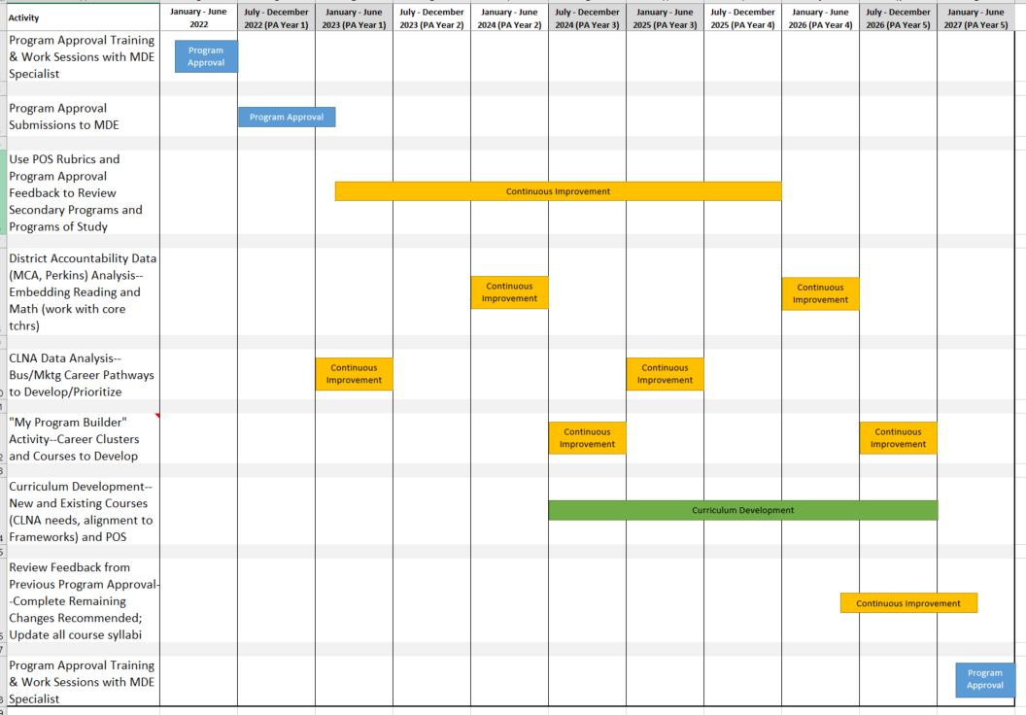

Figure 14: Timeline of Suggested Continuous Improvement Activities

### Local Curriculum Review Cycle

Local school districts have a wide variety of methods for organizing and carrying out a curriculum review cycle. The frequency and objectives of these reviews will also vary. Aspects that may reviewed include:

* Review of student performance data
* Review of current curriculum and technology resources
* Review of proposals for new curriculum and technology resources

Obviously, local objectives must take priority during this locally-controlled process. It is recommended that career and technical education programs also include the following elements during a local curriculum review:

* Analysis of regional CLNA data—industry trends and projected workforce needs
* Comparison of current course alignment to these projected workforce needs
* Proposals for course changes aligned to projected workforce needs
* Analysis of Performance Indicators and Benchmarks in the Minnesota Business Frameworks for aligning existing and new courses to meet projected workforce needs

Career and Technical Education specialists from MDE are available to assist with presentations on CLNA, Frameworks alignment, and Program Approval. It is recommended that the Minnesota Business Frameworks and the Business Table C be included as resource materials for local curriculum review committees as curriculum and budget decisions are being made.